HIT 140: Foundation of Data Science
Group Assignment 2:
Task 1: Ball Possession
FIFA World Cup 2026 Analysis
Instructions
All the terrific matches of the FIFA World Cup 2026 have just ended. Advances in technology and football analytics leave a fascinating trove of team-level and player-level data from the following websites:
- FIFA Official Website: https://www.fifa.com/en/tournaments/mens/worldcup/canadamexicousa2026/statistics
- The Stats Don't Lie: https://www.thestatsdontlie.com/football/world-cup-2026/
- FB Ref: https://fbref.com/en/
Objective 1
Your team will perform four (4) distinct analytic tasks that analyse any of the FIFA World Cup 2026 datasets above using Python. You are free to decide the specific tasks to carry out, as long as each task adheres to the requirements below.
Each analytic task must be driven by a distinct question that will be answered using all the following skills:
- Analytic question formulation
- Data wrangling
- Data preparation and sampling
- Descriptive statistics
- Inferential statistics (Confidence interval)
- Inferential statistics (either a One-Sample t-Test OR a Two-sample t-Test)
Each analytic task must also have a distinct focal point of investigation that differs from the other tasks. For instance, two tasks that focus on analysing the number of goals are not considered distinct and will only be considered as one task.
Task 1
- The Analytic Question
Did the match winners in the FIFA 2026 World Cup matches have more ball possession than the losing team?
The focus of this analysis is to determine whether the team with higher ball possession during the match won. The analysis focuses solely on matches with a winner, regardless of whether the win came in the first 90 minutes, in extra time, or on penalties, and excludes matches that ended in a draw.
- Data wrangling
The dataset was extracted and obtained from the FIFA official website and loaded into an Excel sheet. The data detailed all 104 games, each team’s goals, and ball possession, among other game details, for a total of 104 rows and 12 columns. 20 matches that ended in a draw were removed from the dataset because they were not significant for the analysis of team ball possession and winning capacity. The 84 remaining rows were mapped, and the columns were renamed to reflect the winner and loser data rather than maintaining the initial Excel sheet's Home and Away Column headers. The mapping relied entirely on whether the winning team was the home team or the Away team. Finally, a new variable was derived by finding the difference between the winner's and the loser's ball possession and assigned the variable possession gap. A positive number indicated that the winner had a higher ball possession, while a negative number indicated that the winner had less possession.
- Data preparation and sampling
The 2026 FIFA World Cup ball possession data was obtained from the official FIFA World Cup website. Since the 2026 FIFA World Cup has ended, all the data is available. There were 104 games played in total, of which 84 had a clear winner, and 20 ended in a draw. The 104 matches played constitute the population of interest in this analytic task, whereas 20 matches were not included in the analysis by design because a drawn match has no definitive winner or loser (N= 84). Thus, its results are not informative in answering the analytic question. A simple sampling technique was used, and data validation was performed to ensure that the sample accurately represented the population. The sampling was random, and the sample size obtained was 40 matches (n = 40) drawn from the population size (N). After filtering, data checks showed no missing data, and the data were sufficient to form a hypothesis. Moreover, the sample size was 40, which is greater than 30, thus justifying the use of the Central Limit Theorem for a t-test on the sample mean.
- Descriptive statistics
The count refers to the sample size randomly selected for this analysis (n=40). The possession gap is the difference between the winner's possession and the loser's possession. The summary of the descriptive statistics is shown in Figure 1 below.

Figure 1:Box Plot
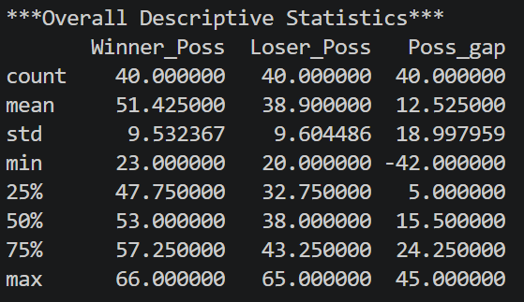
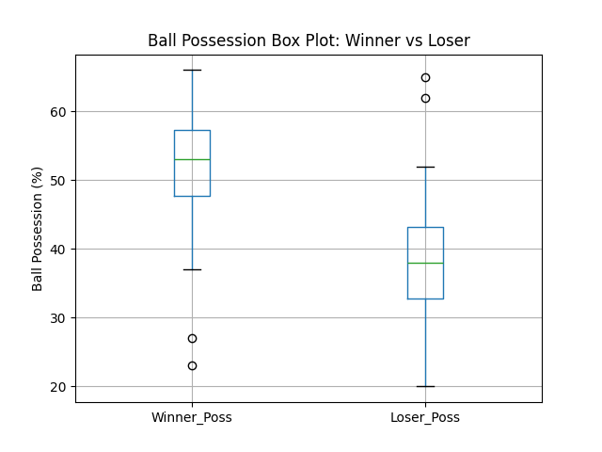The possession is measured in percentage. The winners have a higher mean possession percentage (51.425%) than the average for the losing teams (38.9%). This implies that, on average, the winners in each match of the tournament dominated the ball possession.
Figure 2 : Descriptive Statistics

The histogram in Figure 2 below, backed by the statistics above, shows that the standard deviation of the possession gap is high, indicating substantial variance in ball possession between winners and losers. The cause of this high variance and long tails can be linked to matches where the winners had significantly lower percentages, as seen in Turkey beating Paraguay with 19% possession, while Paraguay had 67%. Another scenario is Germany losing to Paraguay despite having 65% ball possession during the match.
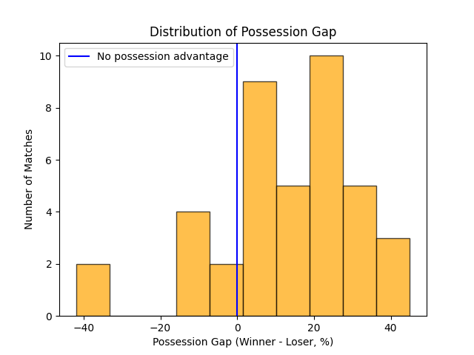Figure 3: Histogram
Normality Test
The analysis employed the Shapiro-Wilk test to assess whether the data were normally distributed at the 5% significance level. The hypothesis for the test states that;
$$H_{0}:The population conforms to a normal distribution$$
$$H_{1}:The population does not conform to a normal distribution$$
Figure 4: Shapiro_Wilk Test
The p-value obtained is 0.0773, which is greater than 0.05; the null hypothesis is not rejected. The conclusion is that the population is normally distributed.

- Inferential statistics (Confidence interval)
The statistics considered in determining the confidence interval include a randomly selected sample size of 40 matches, the mean (12.525), standard deviation (18.99), the standard error (3), and 39 degrees of freedom (n-1). It is worth noting that all the values are in percentages. The obtained confidence interval is [6.449, 18.601].
Figure 5: Confidence Interval
The interval limits are above zero, thus supporting that there is 95% confidence that the possession gap of the winner falls anywhere between the lower and the upper limit. Therefore, we are 95% confident that the winners dominate possession of the ball. The 12.2-point interval difference reflects variability in the population data and serves as a caution against drawing a conclusion based on a single point estimate of the mean possession gap.
- Inferential statistics (t-test)
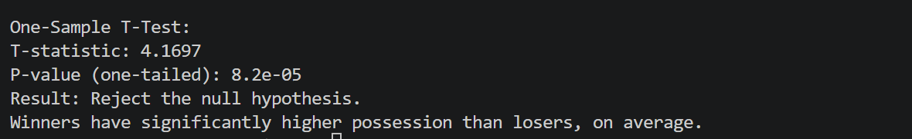
Figure 6: One Sample t-test
The analysis employed a parametric t-test since the two conditions of the central limit theorem are met. The population follows a normal distribution, and the sample size is 40, which exceeds the required 30 data points. The T-statistic at 39 degrees of freedom, as in Figure 6 above, equals 4.1696 with a p-value of 0.00008. The null hypothesis states that on average, there is no advantage in ball possession for the winners. The alternative hypothesis states that on average, the winners hold more ball possession.
$$H_{0}: μ \left(Possession_{_}Gap\right)=0$$
$$H_{1}: μ \left(Possession_{_}Gap\right)>0$$
A p-value of 0.00008, less than 0.05, indicates statistical significance and provides strong evidence to reject the null hypothesis. The conclusion is that on average, winners had more ball possession than losers in the FIFA World Cup 2026.

